WeCamp Batch 11 – Week 1 – Session 2 Homework
1. Navigate to the training demo directory
First, I will create the training_demo folder, by using the command below:
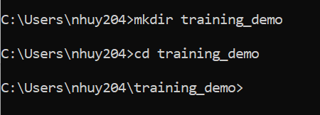
2. Ensure Git tracking
I initialize a local repository to allow Git to start managing versions for this directory.
3. Create a .js file and add code
Create a .js file named hello.js using Notepad
4. Check status
The output shows that the app.js file is currently untracked
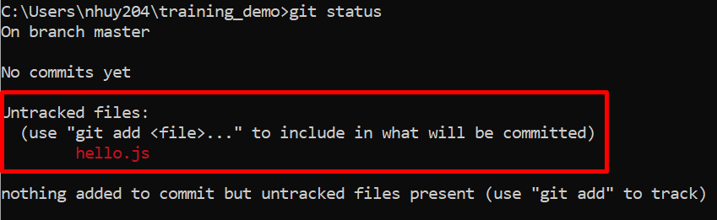5. Stage file
Then add the hello.js file to the Staging Area in preparation for saving.
6. Commit
Then I saved the state of the files currently in the Staging Area to Git's history, along with a message like this below:
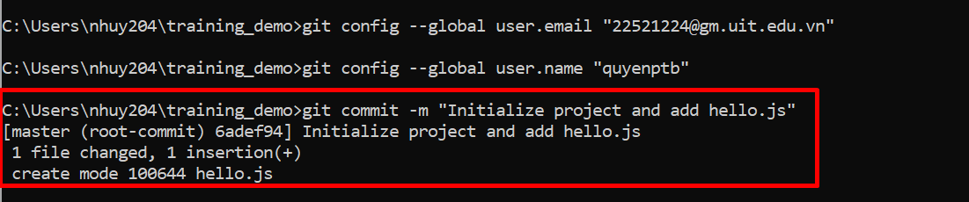

7. View history
I use “git log” to review the history of the commits I have just made.
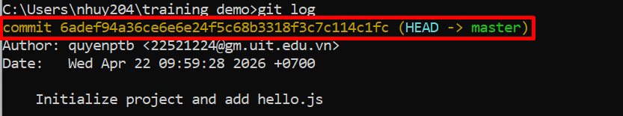
8. Create a new branch and switch to it
I will name the new branch week-01/session-02.
9. Create a new file
While on this new branch, I create another file, which is helper.js.
10. Stage & commit
Repeat the process of adding the file to the Staging Area and committing it but this time I use the new branch.
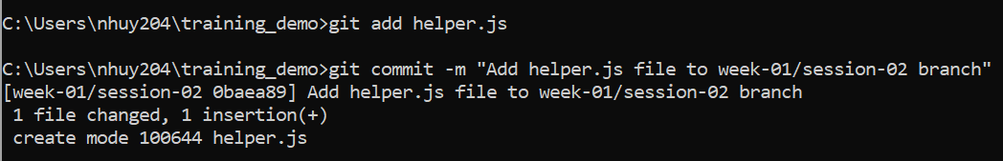
11. Return to main & check
I switch back to the main branch (usually main or master) and check if the helper.js file exists there:
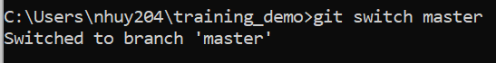
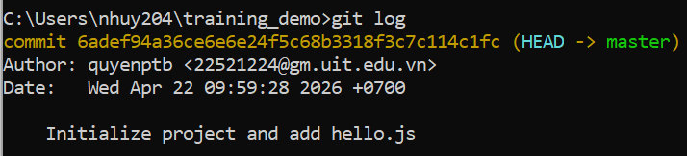
12. Merge branch
Integrate the changes, the helper.js file, from the feature-new branch into my current main (master) branch.
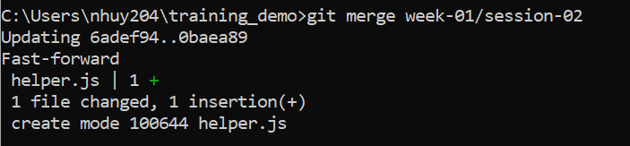
Then I push the files to my existed github repository:
